A cooler day so I was able to spend more time with it. Tried several things yesterday with two memory cards, ended up with the original chip. Left out putting in local host in opencpn. Put it in and rebooted.
Here is the system check file:
Checking touchscreen optimization... | disabled
Checking backlight... | disabled
Checking Power off management... | disabled
Checking Shutdown management... | disabled
Checking OpenPlotter autostart... | enabled
Checking rescue mode... | disabled
Checking debugging mode... | disabled
Checking system log file size... | System log file size: 12.39 MB
Checking OpenPlotter packages source... | added
Checking SDR processes... | SDR AIS is not running
Checking Notifications... | running
↳The access request must be aproved with read/write permission in Signal K administrator.
Checking GPIO... | pigpiod running | Seatalk1 disabled | 1W enabled | pulses disabled | digital disabled | openplotter-gpio-read not running
↳The access request must be aproved with read/write permission in Signal K administrator.
Checking I2C sensors... | openplotter-i2c-read running | I2C enabled | Access to Signal K server validated
Checking Network... | access point disabled | NTP server not running
Checking serial connections alias... | All your serial connections have an assigned alias
Checking Dashboards... | Grafana running | Influxdb running | Telegraf running | SailGauge enabled
Checking OpenCPN... | running | | autostart disabled | FP autostart enabled
↳OpenCPN shortcut is broken, click "Install" in OpenCPN Installer app to rebuild it.
Checking Signal K server... | running
Checking serial connections conflicts... | no conflicts
Checking network connections conflicts... | no conflicts
Checking GPIO conflicts... | no conflicts
CHECK SYSTEM FINISHED
No communication with the N2K network. This is not the first time I’ve got the OpenCPN shortcut is broken, click "Install" in OpenCPN Installer app to rebuild it.
Tried yesterday to reinstall it and it failed. Wants you to check versions first, which took over 20 minutes yesterday and failed. First time today, on the marina network it failed. Switched to the smartphone and access point, and was able to: check the versions, install the new version of opencpn that was waiting.
Rebooted the Pi.
Here is the log:
Starting Notifications... | Notifications started
Starting GPIO... | No GPIO defined
Starting I2C sensors... | I2C sensors started
Starting Dashboards... | Telegraf started
Starting OpenCPN... | non fullscreen
Checking touchscreen optimization... | disabled
Checking backlight... | disabled
Checking Power off management... | disabled
Checking Shutdown management... | disabled
Checking OpenPlotter autostart... | enabled
Checking rescue mode... | disabled
Checking debugging mode... | disabled
Checking system log file size... | System log file size: 12.53 MB
Checking OpenPlotter packages source... | added
Checking SDR processes... | SDR AIS is not running
Checking Notifications... | running
↳The access request no longer exists.
Checking GPIO... | pigpiod running | Seatalk1 disabled | 1W enabled | pulses disabled | digital disabled | openplotter-gpio-read not running
↳The access request no longer exists.
Checking I2C sensors... | openplotter-i2c-read running | I2C enabled | Access to Signal K server validated
Checking Network... | access point disabled | NTP server not running
Checking serial connections alias... | All your serial connections have an assigned alias
Checking Dashboards... | Grafana running | Influxdb running | Telegraf running | SailGauge enabled
Checking OpenCPN... | running | | autostart disabled | FP autostart enabled
↳OpenCPN shortcut is broken, click "Install" in OpenCPN Installer app to rebuild it.
Checking Signal K server... | running
Checking serial connections conflicts... | no conflicts
Checking network connections conflicts... | no conflicts
Checking GPIO conflicts... | no conflicts
STARTUP FINISHED
Here is the proof of update
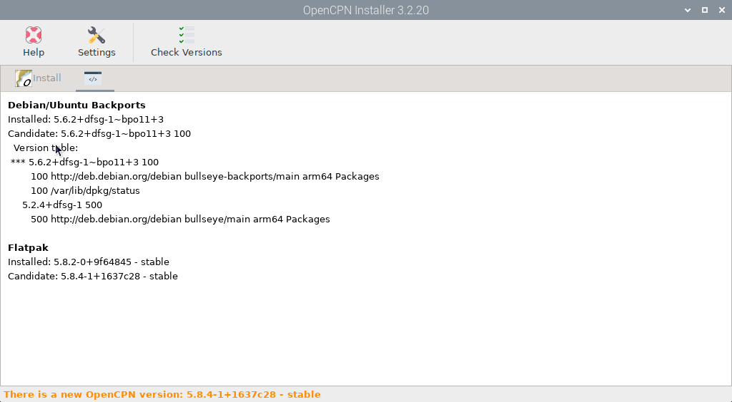
Same error message. OpenCPN shortcut is broken, click "Install" in OpenCPN Installer app to rebuild it.
Still no data from the n2k network.
Next I ran updates from the terminal and rebooted.
Got the next log:
Starting Notifications... | Notifications started
Starting GPIO... | No GPIO defined
Starting I2C sensors... | I2C sensors started
Starting Dashboards... | Telegraf started
Starting OpenCPN... | non fullscreen
Checking touchscreen optimization... | disabled
Checking backlight... | disabled
Checking Power off management... | disabled
Checking Shutdown management... | disabled
Checking OpenPlotter autostart... | enabled
Checking rescue mode... | disabled
Checking debugging mode... | disabled
Checking system log file size... | System log file size: 13.3 MB
Checking OpenPlotter packages source... | added
Checking SDR processes... | SDR AIS is not running
Checking Notifications... | running
↳The access request no longer exists.
Checking GPIO... | pigpiod running | Seatalk1 disabled | 1W enabled | pulses disabled | digital disabled | openplotter-gpio-read not running
↳The access request no longer exists.
Checking I2C sensors... | openplotter-i2c-read running | I2C enabled | Access to Signal K server validated
Checking Network... | access point disabled | NTP server not running
Checking serial connections alias... | All your serial connections have an assigned alias
Checking Dashboards... | Grafana running | Influxdb running | Telegraf running | SailGauge enabled
Checking OpenCPN... | running | | autostart disabled | FP autostart enabled
↳OpenCPN shortcut is broken, click "Install" in OpenCPN Installer app to rebuild it.
Checking Signal K server... | running
Checking serial connections conflicts... | no conflicts
Checking network connections conflicts... | no conflicts
Checking GPIO conflicts... | no conflicts
STARTUP FINISHED
No data from N2k network.
Note, the pi was still showing a considerable number of updates available in the top menu bar.
I’m getting data from the I2c port.
Here is a typical dashboard after the changes. Wsetc is the I2c.
The next screen shows the connections. The original one for the garmin handheld is there and another for the actisense. As expected from my original memory card. But no conflicts. Removed the garmin connection from the chip yesterday in opencpn.

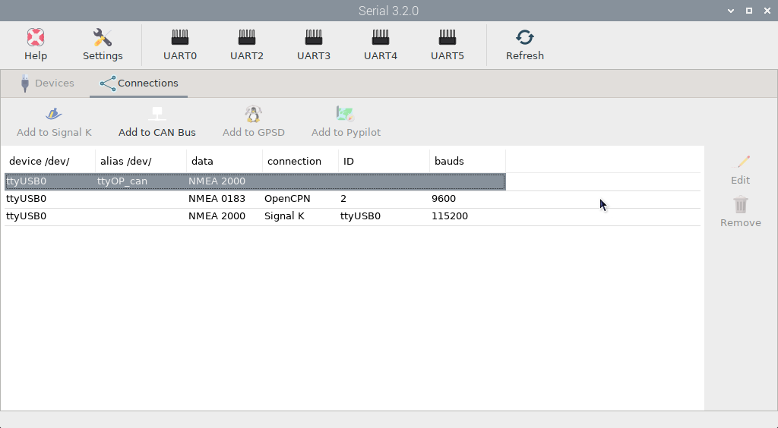

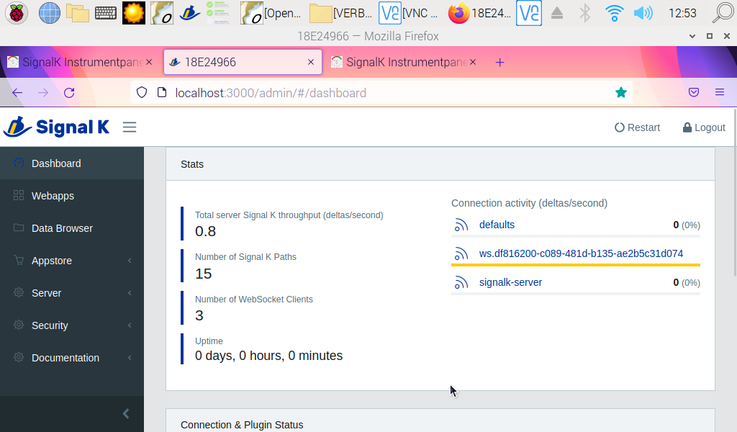
Note no data on the signalk server.
This is what it used to look like a couple of weeks ago before the problems started.
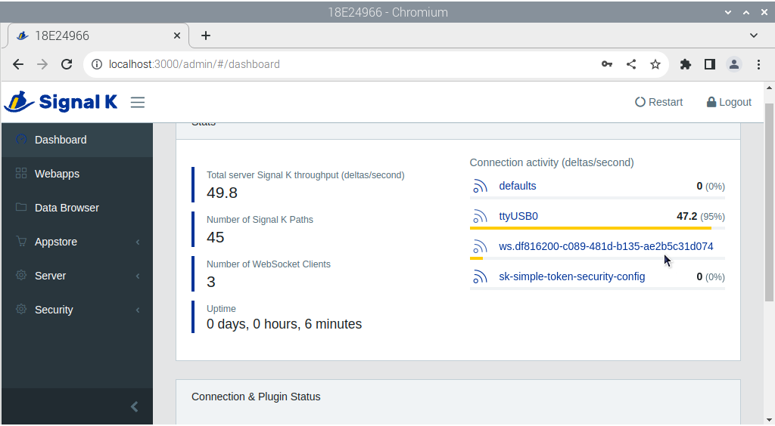

When I set up open plotter at home originally in May, I added a number of signalk apps to see what they might do. I have got rid of most on the chips I was using, but cannot get rid of them on this chip.
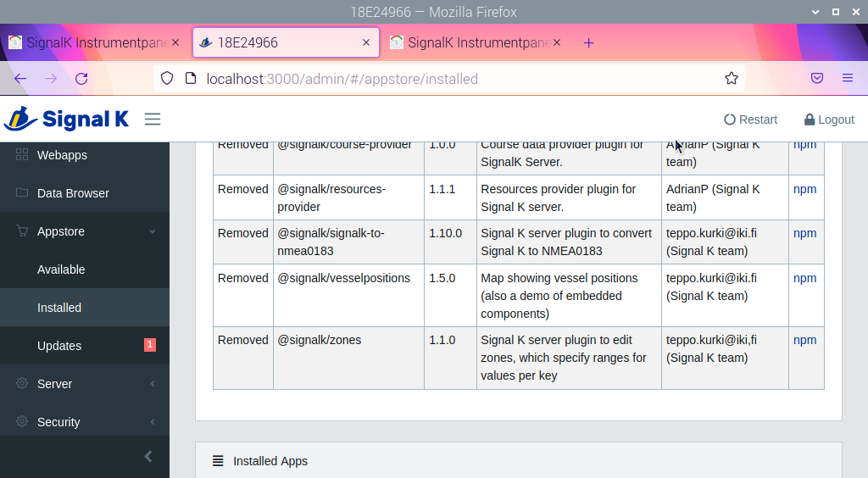 Get a list of removed apps, reboot to see what happens, and they are back. 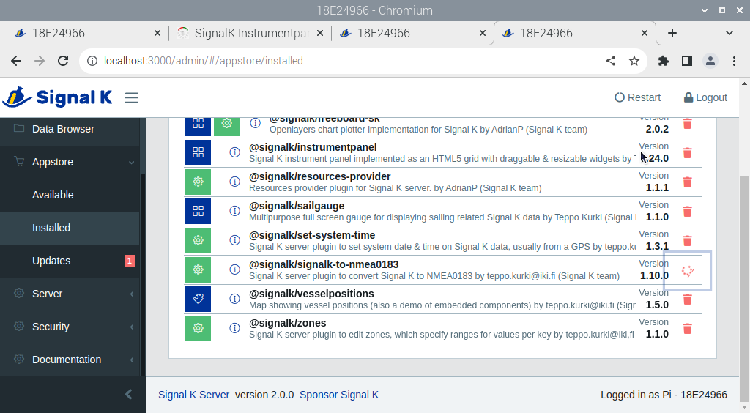

Not getting any data stored on the chip either. Added the extra / as suggested. 