You were asking about the garmin handheld settings in opencpn. They are gone now but would have looked like open cpn settings on his laptop. Unchecked the box when I put the Pi on the boat.
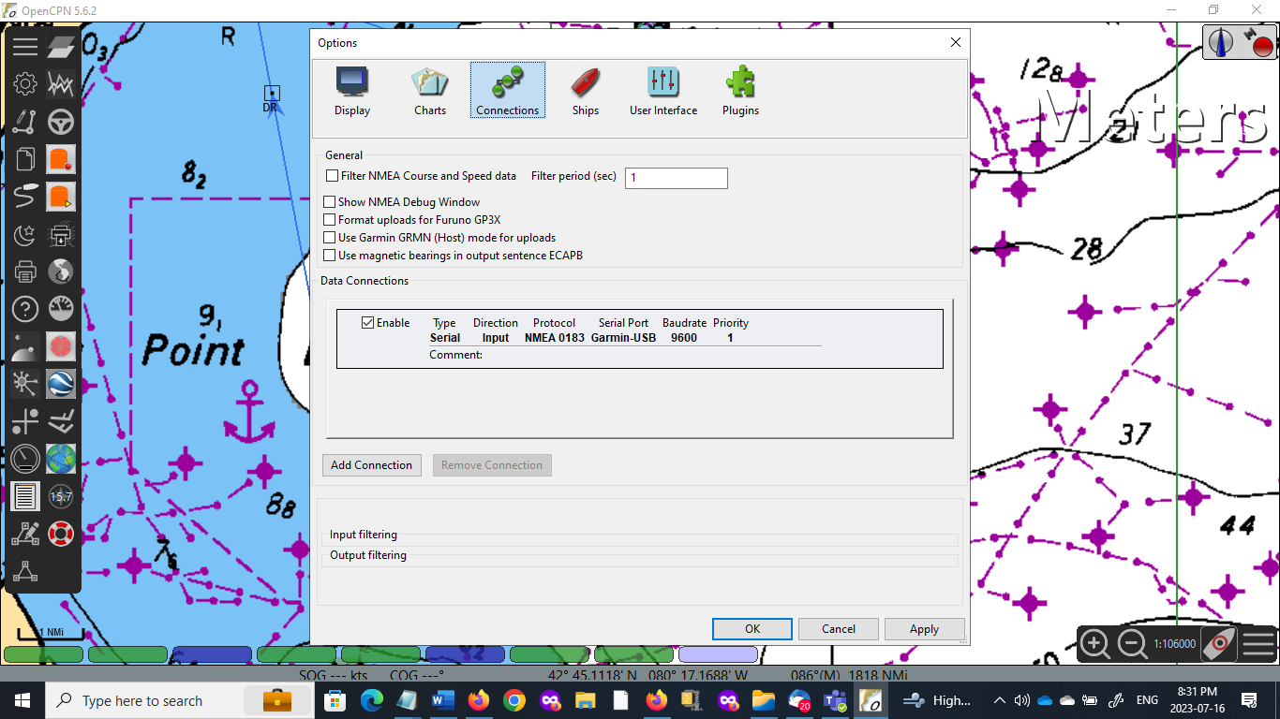
I was at the boat today and ran into more issues. The Pi was locked so I rebooted it, and everything went fine.
I tried to install the signalk upgrade with the phone as a hotspot instead of the marina connection. Something went wrong, and don’t know what.
Here is the system check file
Checking touchscreen optimization... | disabled
Checking backlight... | disabled
Checking Power off management... | disabled
Checking Shutdown management... | disabled
Checking OpenPlotter autostart... | enabled
Checking rescue mode... | disabled
Checking debugging mode... | disabled
Checking system log file size... | System log file size: 2.87 MB
Checking OpenPlotter packages source... | added
Checking SDR processes... | SDR AIS is not running
Checking Notifications... | running
↳Error requesting access to Signal K server: HTTPConnectionPool(host='localhost', port=3000): Max retries exceeded with url: /signalk/v1/access/requests (Caused by NewConnectionError('<urllib3.connection.HTTPConnection object at 0x7f9caed190>: Failed to establish a new connection: [Errno 111] Connection refused')).
Checking GPIO... | pigpiod running | Seatalk1 disabled | 1W enabled | pulses disabled | digital disabled | openplotter-gpio-read not running
↳Error requesting access to Signal K server: HTTPConnectionPool(host='localhost', port=3000): Max retries exceeded with url: /signalk/v1/access/requests (Caused by NewConnectionError('<urllib3.connection.HTTPConnection object at 0x7f77dcb670>: Failed to establish a new connection: [Errno 111] Connection refused')).
Checking I2C sensors... | I2C enabled
↳openplotter-i2c-read not running
Error requesting access to Signal K server: HTTPConnectionPool(host='localhost', port=3000): Max retries exceeded with url: /signalk/v1/access/requests (Caused by NewConnectionError('<urllib3.connection.HTTPConnection object at 0x7f77dcb3a0>: Failed to establish a new connection: [Errno 111] Connection refused')).
Checking Network... | NTP server running | correct access point password
Checking serial connections alias... | All your serial connections have an assigned alias
Checking Dashboards... | Grafana running | Influxdb running | Telegraf running
Checking OpenCPN... | running | | autostart disabled | FP fullscreen autostart enabled
↳OpenCPN shortcut is broken, click "Install" in OpenCPN Installer app to rebuild it.
The default OpenCPN connection is missing and is not getting data from Signal K. Please create this connection in OpenCPN:
Network
Protocol: Signal K
Address: localhost
DataPort: 3000
Automatic server discovery: not
Checking Signal K server...
↳Signal K server is not running
Checking serial connections conflicts... | no conflicts
Checking network connections conflicts... | no conflicts
Checking GPIO conflicts... | no conflicts
CHECK SYSTEM FINISHED
This is what I get in firefox or chromium, next to boxes.
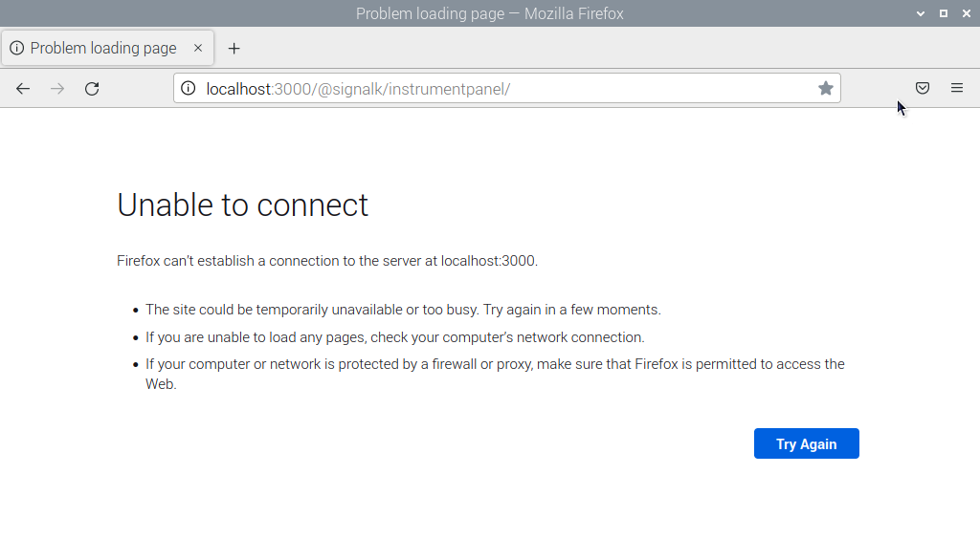
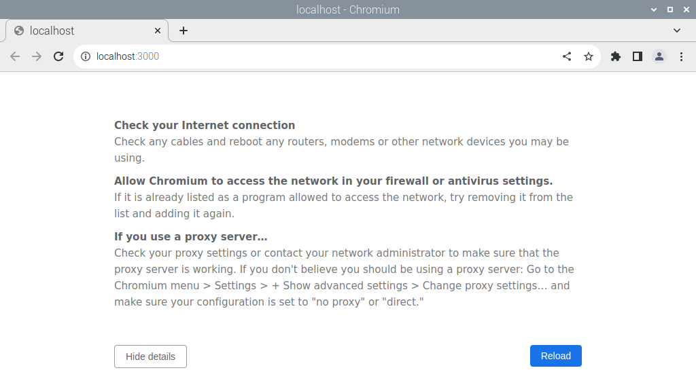
Rebooted and no difference. Tried to reinstall signalk, no difference.
Must have really screwed something up.

