Went through the system trying several things.
Opencpn after it starts.
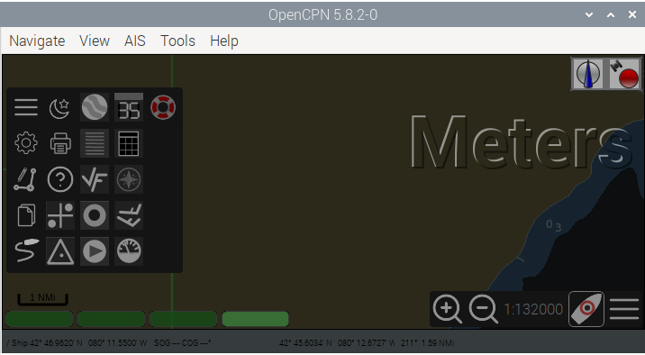
Went in and removed the ntg-1 connection from the Pi. Removed signalk connection from Opencpn and rebooted. Did a system check. Below. Note the highlighted errors we got before.
Checking touchscreen optimization... | disabled
Checking backlight... | disabled
Checking Power off management... | disabled
Checking Shutdown management... | disabled
Checking OpenPlotter autostart... | enabled
Checking rescue mode... | disabled
Checking debugging mode... | disabled
Checking system log file size... | System log file size: 4.81 MB
Checking OpenPlotter packages source... | added
Checking SDR processes... | SDR AIS is not running
Checking Notifications... | running
↳Error requesting access to Signal K server: HTTPConnectionPool(host='localhost', port=3000): Max retries exceeded with url: /signalk/v1/access/requests (Caused by NewConnectionError('<urllib3.connection.HTTPConnection object at 0x7fa20aa160>: Failed to establish a new connection: [Errno 111] Connection refused')).
Checking GPIO... | pigpiod running | Seatalk1 disabled | 1W enabled | pulses disabled | digital disabled | openplotter-gpio-read not running
↳Error requesting access to Signal K server: HTTPConnectionPool(host='localhost', port=3000): Max retries exceeded with url: /signalk/v1/access/requests (Caused by NewConnectionError('<urllib3.connection.HTTPConnection object at 0x7f96b7f640>: Failed to establish a new connection: [Errno 111] Connection refused')).
Checking I2C sensors... | I2C enabled
↳openplotter-i2c-read not running
Error requesting access to Signal K server: HTTPConnectionPool(host='localhost', port=3000): Max retries exceeded with url: /signalk/v1/access/requests (Caused by NewConnectionError('<urllib3.connection.HTTPConnection object at 0x7f96b7f370>: Failed to establish a new connection: [Errno 111] Connection refused')).
Checking Network... | NTP server running | correct access point password
Checking serial connections alias... | All your serial connections have an assigned alias
Checking Dashboards... | Grafana running | Influxdb running | Telegraf running
Checking OpenCPN... | not running | autostart disabled | FP fullscreen autostart enabled
↳OpenCPN shortcut is broken, click "Install" in OpenCPN Installer app to rebuild it.
The default OpenCPN connection is missing and is not getting data from Signal K. Please create this connection in OpenCPN:
Network
Protocol: Signal K
Address: localhost
DataPort: 3000
Automatic server discovery: not
Checking Signal K server...
↳Signal K server is not running
Checking serial connections conflicts... | no conflicts
Checking network connections conflicts... | no conflicts
Checking GPIO conflicts... | no conflicts
CHECK SYSTEM FINISHED
I then put the signalk connection back into OPENCPN and plugged in the Actisence NTG-1.
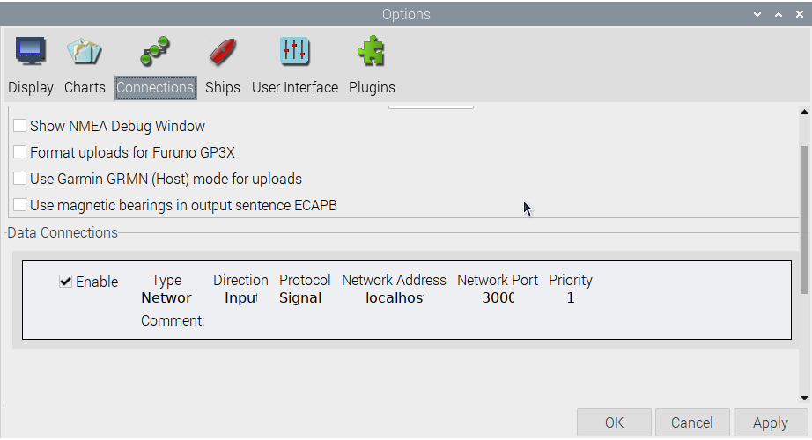
Checked every routine
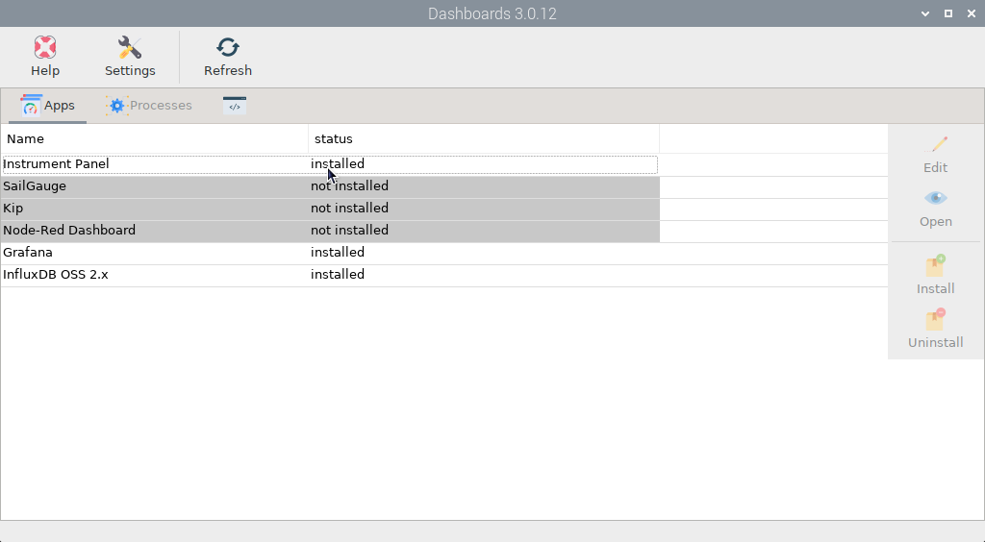
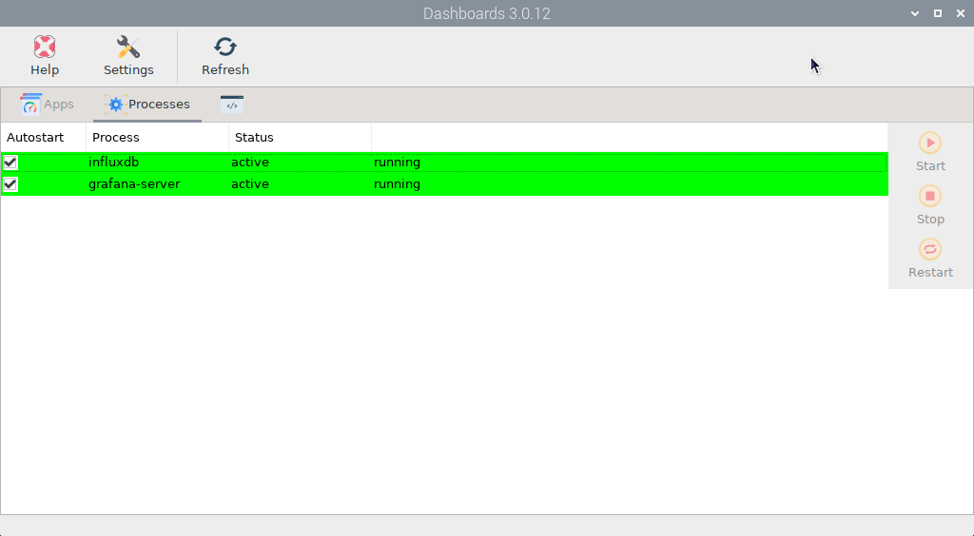
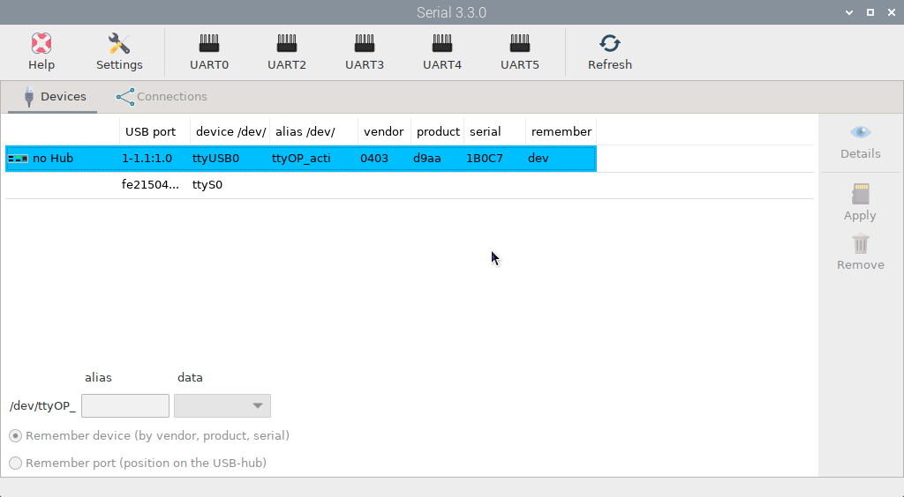
Clicked the connection
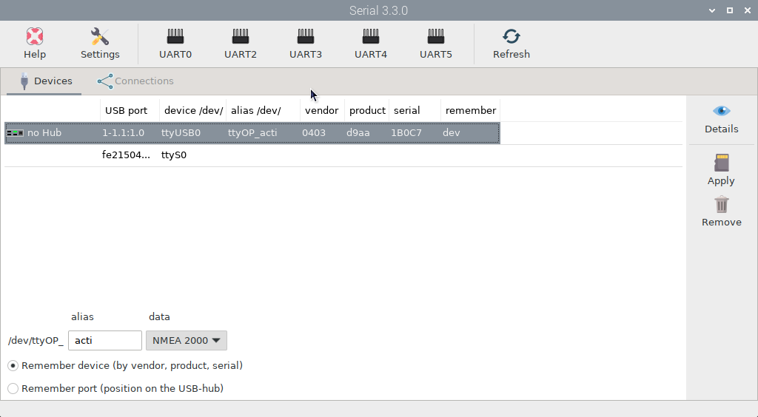
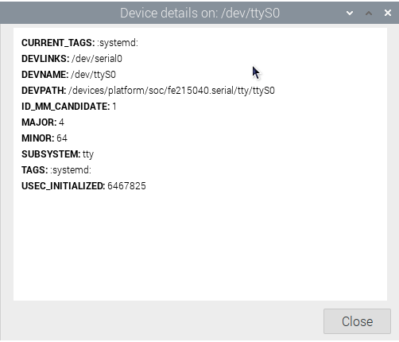
Actisense ntg-1 connection details.
CURRENT_TAGS: :systemd:
DEVLINKS: /dev/ttyOP_acti /dev/serial/by-path/platform-fd500000.pcie-pci-0000:01:00.0-usb-0:1.1:1.0-port0
DEVNAME: /dev/ttyUSB0
DEVPATH: /devices/platform/scb/fd500000.pcie/pci0000:00/0000:00:00.0/0000:01:00.0/usb1/1-1/1-1.1/1-1.1:1.0/ttyUSB0/tty/ttyUSB0
ID_BUS: pci
ID_MM_CANDIDATE: 1
ID_MODEL_FROM_DATABASE: VL805 USB 3.0 Host Controller
ID_MODEL_ID: 0x3483
ID_PATH: platform-fd500000.pcie-pci-0000:01:00.0-usb-0:1.1:1.0
ID_PATH_TAG: platform-fd500000_pcie-pci-0000_01_00_0-usb-0_1_1_1_0
ID_PCI_CLASS_FROM_DATABASE: Serial bus controller
ID_PCI_INTERFACE_FROM_DATABASE: XHCI
ID_PCI_SUBCLASS_FROM_DATABASE: USB controller
ID_USB_DRIVER: ftdi_sio
ID_USB_INTERFACES: :ffffff:
ID_USB_INTERFACE_NUM: 00
ID_USB_MODEL: NGT-1-A
ID_USB_MODEL_ENC: NGT-1-A
ID_USB_MODEL_ID: d9aa
ID_USB_REVISION: 0600
ID_USB_SERIAL: Actisense_NGT-1-A_1B0C7
ID_USB_SERIAL_SHORT: 1B0C7
ID_USB_TYPE: generic
ID_USB_VENDOR: Actisense
ID_USB_VENDOR_ENC: Actisense
ID_USB_VENDOR_ID: 0403
ID_VENDOR_FROM_DATABASE: VIA Technologies, Inc.
ID_VENDOR_ID: 0x1106
MAJOR: 188
MINOR: 0
SUBSYSTEM: tty
TAGS: :systemd:
USEC_INITIALIZED: 11064900

I then rebooted it. No connection to the ntg-1, hence network.
System check
Checking touchscreen optimization... | disabled
Checking backlight... | disabled
Checking Power off management... | disabled
Checking Shutdown management... | disabled
Checking OpenPlotter autostart... | enabled
Checking rescue mode... | disabled
Checking debugging mode... | disabled
Checking system log file size... | System log file size: 5.0 MB
Checking OpenPlotter packages source... | added
Checking SDR processes... | SDR AIS is not running
Checking Notifications... | running
↳Error requesting access to Signal K server: HTTPConnectionPool(host='localhost', port=3000): Max retries exceeded with url: /signalk/v1/access/requests (Caused by NewConnectionError('<urllib3.connection.HTTPConnection object at 0x7f95bf8160>: Failed to establish a new connection: [Errno 111] Connection refused')).
Checking GPIO... | pigpiod running | Seatalk1 disabled | 1W enabled | pulses disabled | digital disabled | openplotter-gpio-read not running
↳Error requesting access to Signal K server: HTTPConnectionPool(host='localhost', port=3000): Max retries exceeded with url: /signalk/v1/access/requests (Caused by NewConnectionError('<urllib3.connection.HTTPConnection object at 0x7f8a6d4640>: Failed to establish a new connection: [Errno 111] Connection refused')).
Checking I2C sensors... | I2C enabled
↳openplotter-i2c-read not running
Error requesting access to Signal K server: HTTPConnectionPool(host='localhost', port=3000): Max retries exceeded with url: /signalk/v1/access/requests (Caused by NewConnectionError('<urllib3.connection.HTTPConnection object at 0x7f8a6d4370>: Failed to establish a new connection: [Errno 111] Connection refused')).
Checking Network... | NTP server running | correct access point password
Checking serial connections alias... | All your serial connections have an assigned alias
Checking Dashboards... | Grafana running | Influxdb running | Telegraf running
Checking OpenCPN... | running | | autostart disabled | FP fullscreen autostart enabled
↳OpenCPN shortcut is broken, click "Install" in OpenCPN Installer app to rebuild it.
The default OpenCPN connection is missing and is not getting data from Signal K. Please create this connection in OpenCPN:
Network
Protocol: Signal K
Address: localhost
DataPort: 3000
Automatic server discovery: not
The default OpenCPN connection is missing and is not getting data from Signal K. Please create this connection in OpenCPN:
Network
Protocol: Signal K
Address: localhost
DataPort: 3000
Automatic server discovery: not
Checking Signal K server...
↳Signal K server is not running
Checking serial connections conflicts... | no conflicts
Checking network connections conflicts... | no conflicts
Checking GPIO conflicts... | no conflicts
CHECK SYSTEM FINISHED
No difference. So I hooked up the phone and reinstalled signalk. Took quite a while. No change.
Shut down the Pi and removed the micro sdhc chip. Replaced with another version. Turned on the Pi.
No data connection to the actisence ntg-1 and network. Did not get the errors as the previous chip. Getting data from the I2c port. Deleted and redid the devices and connections.
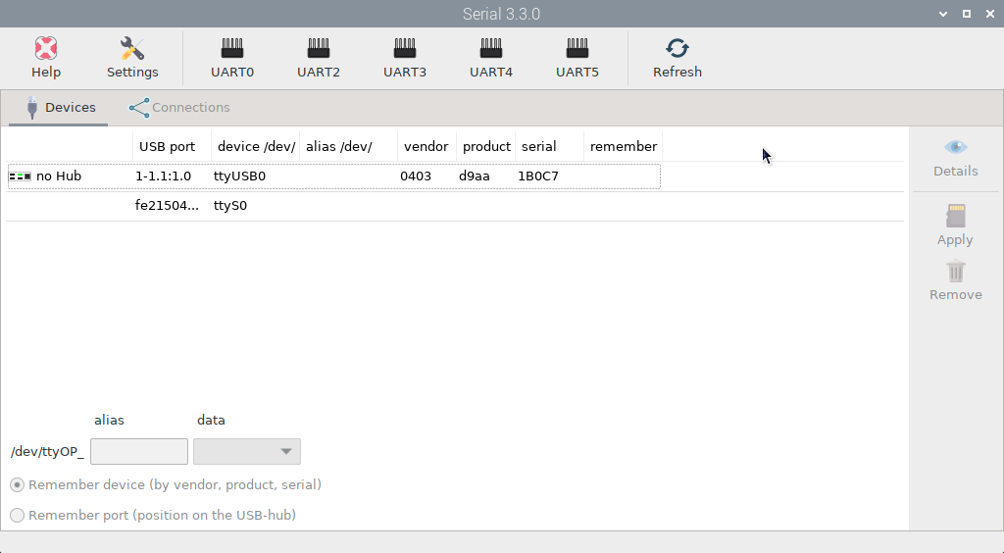
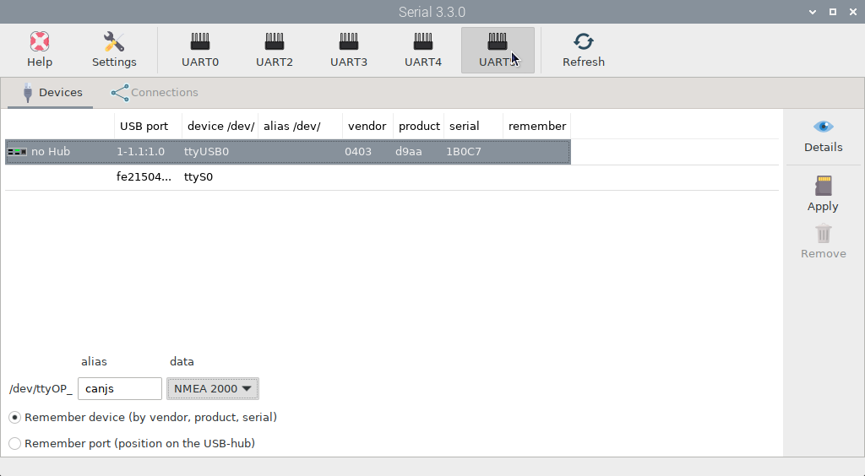
Clicked the connections tab and got this.
