Hi,
I2C setup reply
Remembered my usb drive with the screenshots today.
Here is the i2cdetect results. Both BME280’s are the same. Different manufacturers.

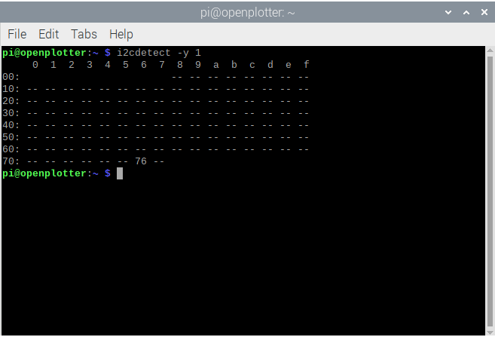

Started a signalk session and logged in. note if I reboot and try the access request it goes to signalk and I log in. does not matter as to what happens next. Started the i2c routine.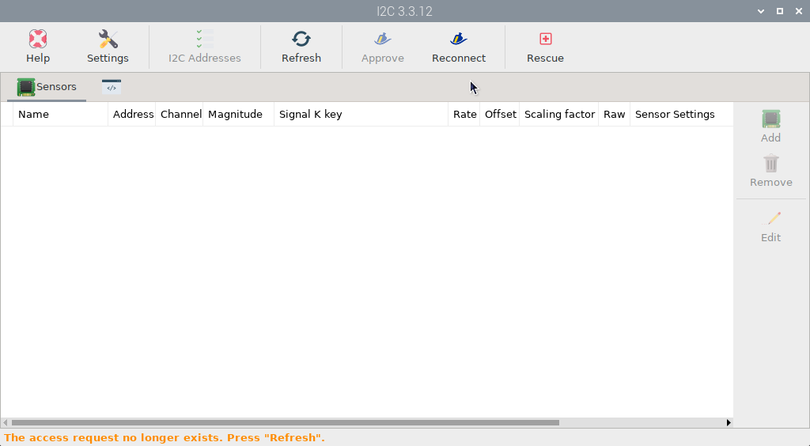
Pressed refresh and get this:
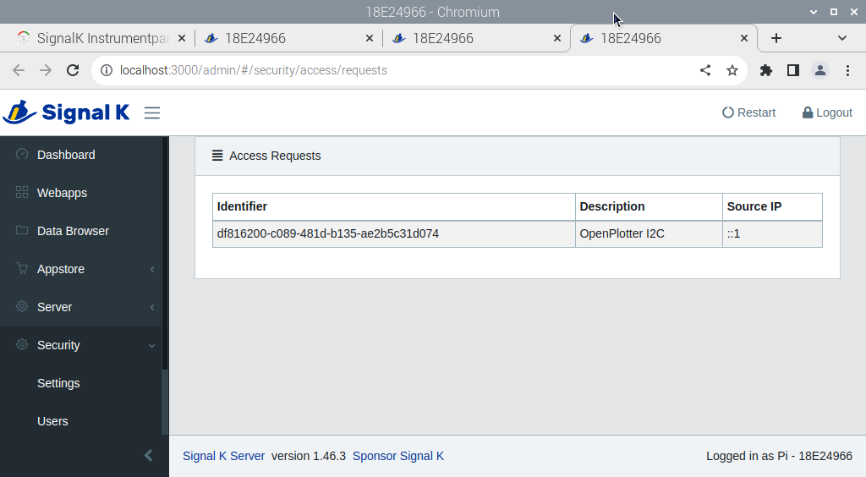
Scrooling down we get this page.
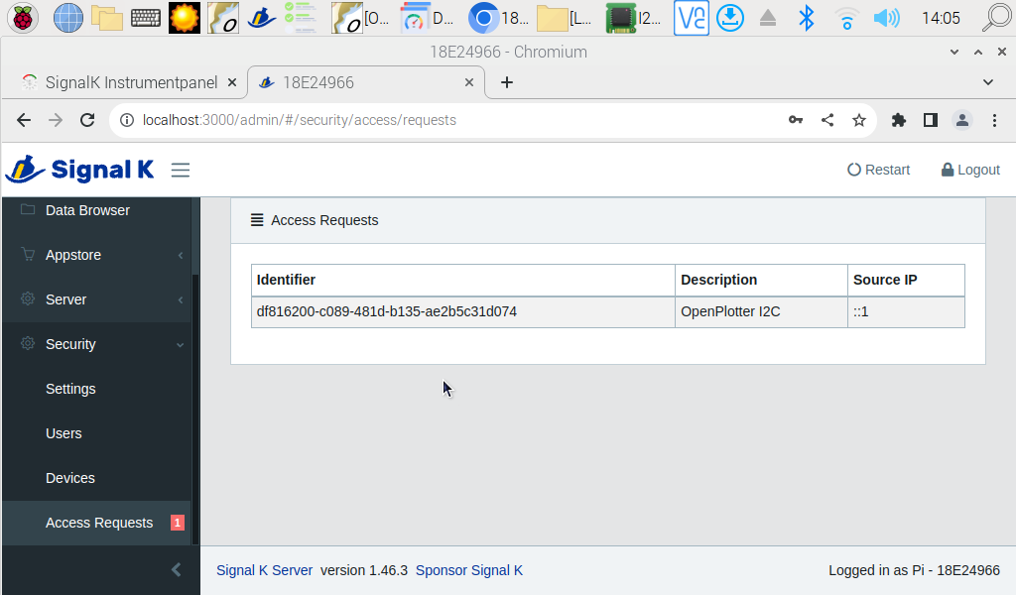
Scrolling down on the left I can find an access request. (could not get it the day before) Clicking it or the identifier on the right I get the next screen, which I filled in, as below and clicked apply. As before. Tried all caps as well for never. No difference. 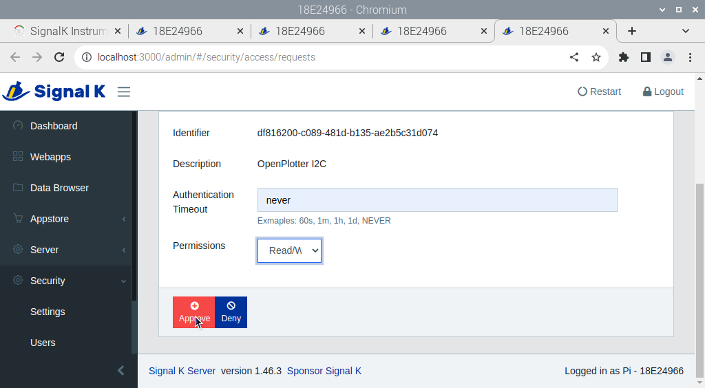

No approval message.
Get the same screen above for I2c. tried multiple times, rebooting several times.
Went looking at various signalk screens afterwards.
The devices screen shows the running. Show’s I2c and GPIO running. Yet I have never seen an approval message. No can I add a sensor.
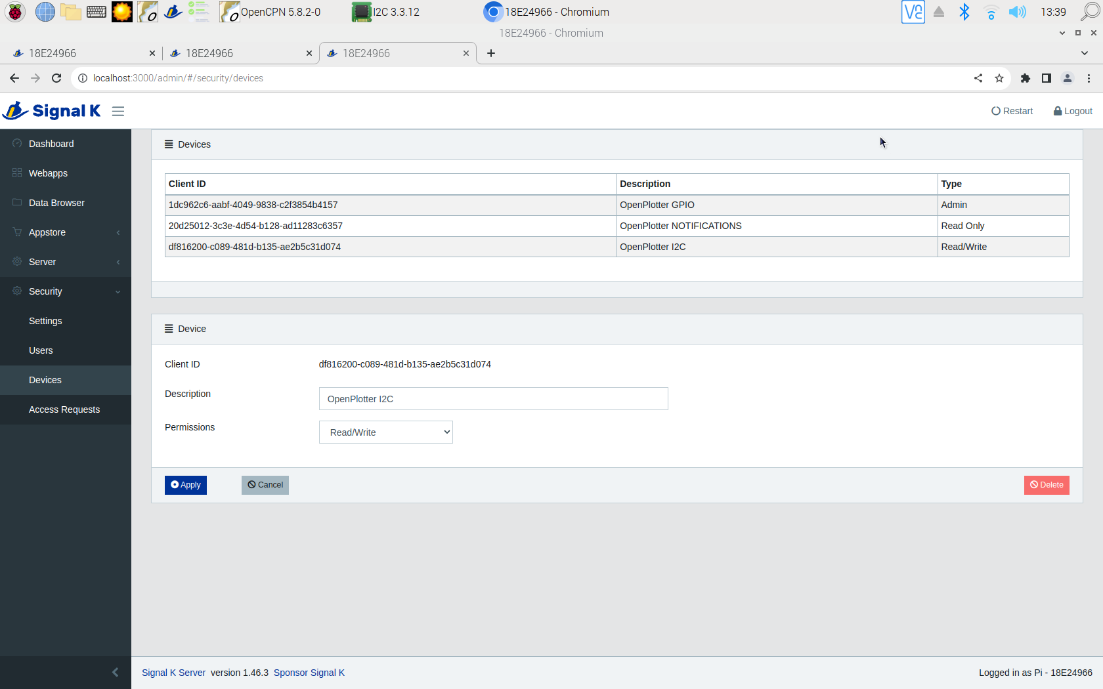
SignalK screen showing connections.
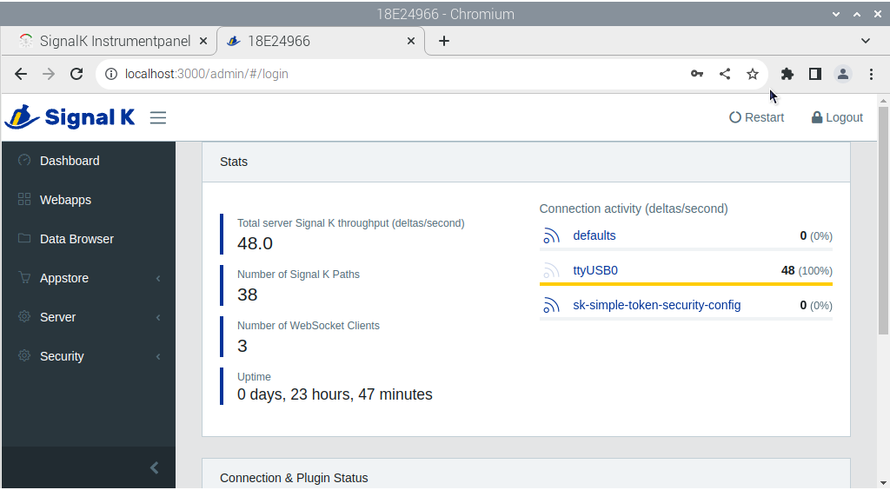
If I look at the data browser, the next two screenshots show the I2c and gpio .
